**DAILY ONLINE ACTIVITIES SUMMARY**

|  |  |  |  |  |  |  |  |
| --- | --- | --- | --- | --- | --- | --- | --- |
| **Date:** | **28/06/2020** | | | | **Name:** | **Churashma** | |
| **Sem & Sec** | **4th SEM 'A' Section** | | | | **USN:** | **4AL18CS019** | |
| **Online Test Summary** | | | | | | | |
| **Subject** | | **No test** | | | | | |
| **Max. Marks** | | **-** | | **Score** | | **-** | |
| **Certification Course Summary** | | | | | | | |
| **Course** | **Introduction to R** | | | | | | |
| **Certificate Provider** | | | **greatlearning academy** | **Duration** | | | **3.5 hours** |
| **Coding Challenges** | | | | | | | |
| **Problem statement 1: C program to convert temperature from Fahrenheit to Celsius and Celsius to Fahrenheit.** | | | | | | | |
| **Status: completed** | | | | | | | |
| **Uploaded the report in Github** | | | | **yes** | | | |
| **If yes Repository name** | | | | **https://github.com/Churashma/Lockdown-coding** | | | |
| **Uploaded the report in slack** | | | | **yes** | | | |

ONLINE TEST DETAILS: No test

CERTIFICATION COURSE DETAILS: Today I studied about case study:house price.This is just one of the many places where regression can be applied. Other applications range from predicting health outcomes in medicine, stock prices in finance, and power usage in high-performance computing, to analyzing which regulators are important for gene expression.

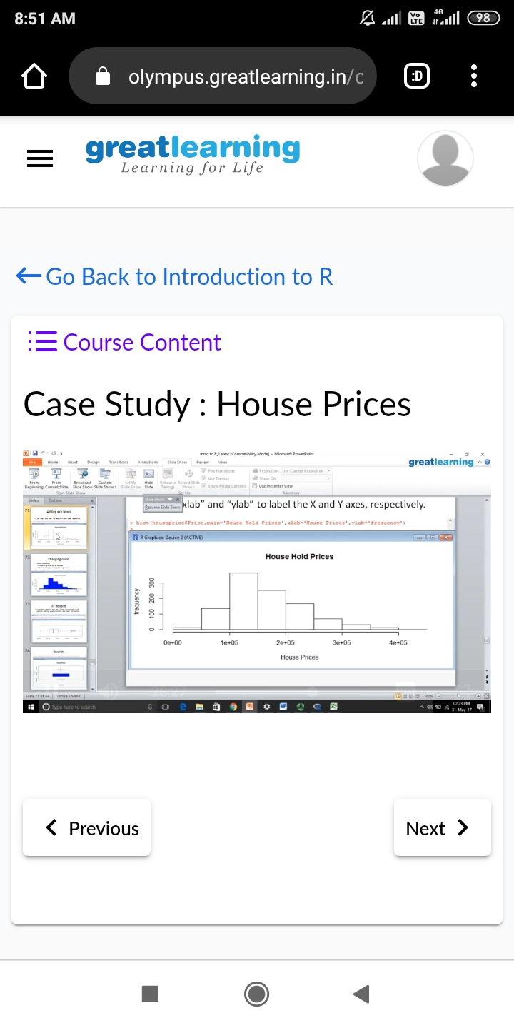

**CODING CHALLENGES DETAILS**:

Problem statement 1: C program to convert temperature from Fahrenheit to Celsius and Celsius to Fahrenheit.

